Patil Dhanashree Rajendra, M.Pharm  Campus Address:  Sant Dnyaneshwar Shikshan Sanstha’s  ANNASAHEB DANGE COLLEGE OF B.PHARMACY [D. PHARM]  Ashta, Tal. Walwa, Dist. Sangli (416301)  Phone: Office: 02342-241125  Cell No. 9423560416  E-mail: ssupadhye7@gmail.com |  |  | 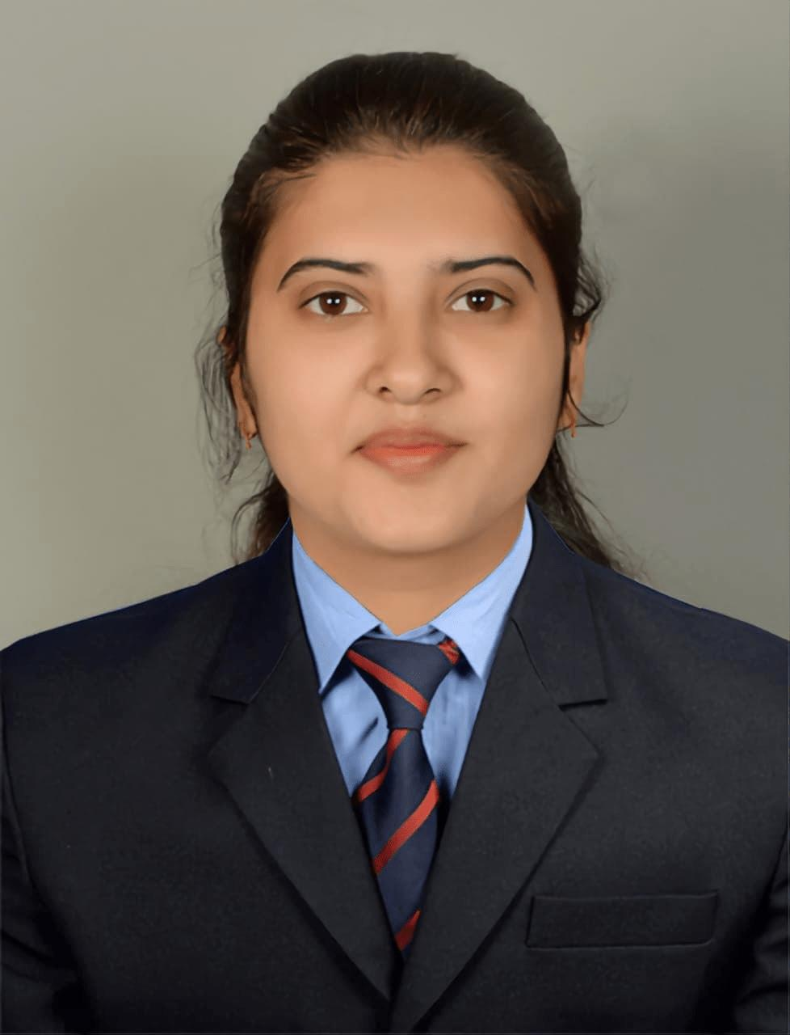
Education:
M.Pharm. (2021): Bharti Vidyapeeth college of Pharmacy, Kolhapur
B. Pharm. (2019): Rajarambapu College of Pharmacy, kasegaon
Professional Work Experience:
Feb 2022 to Feb 2013: Formulation development Department: alkem Laboratories Mumbai
Sept 2023 to july 2024: Lecturer, s.d Patil institute of Pharmacy,Islampur
Oct 2025 : Annasaheb Dange College of B.Pharmacy, Ashta

Teaching | Research | Industry |  | Total
10 Months | 00 Years | 01 Years |  | 1 Years 10 Months
Subject Taught: Diploma- Pharmaceutical chemistry , Pharmacology
Research Foci: Development of Herbal Nano Emulsion for Hair growth promotion

