Miss. Akanksha R. Sawant (M Pharm)  Assistant Professor  Campus Address:  Sant Dnyaneshwar Shikshan Sanstha’s  ANNASAHEB DANGE COLLEGE OF B.PHARMACY [D. PHARM]  Ashta, Tal. Walwa, Dist. Sangli (416301)  Phone: Office: 02342-241125  Cell No. 9421727133  E-mail: |  |  | 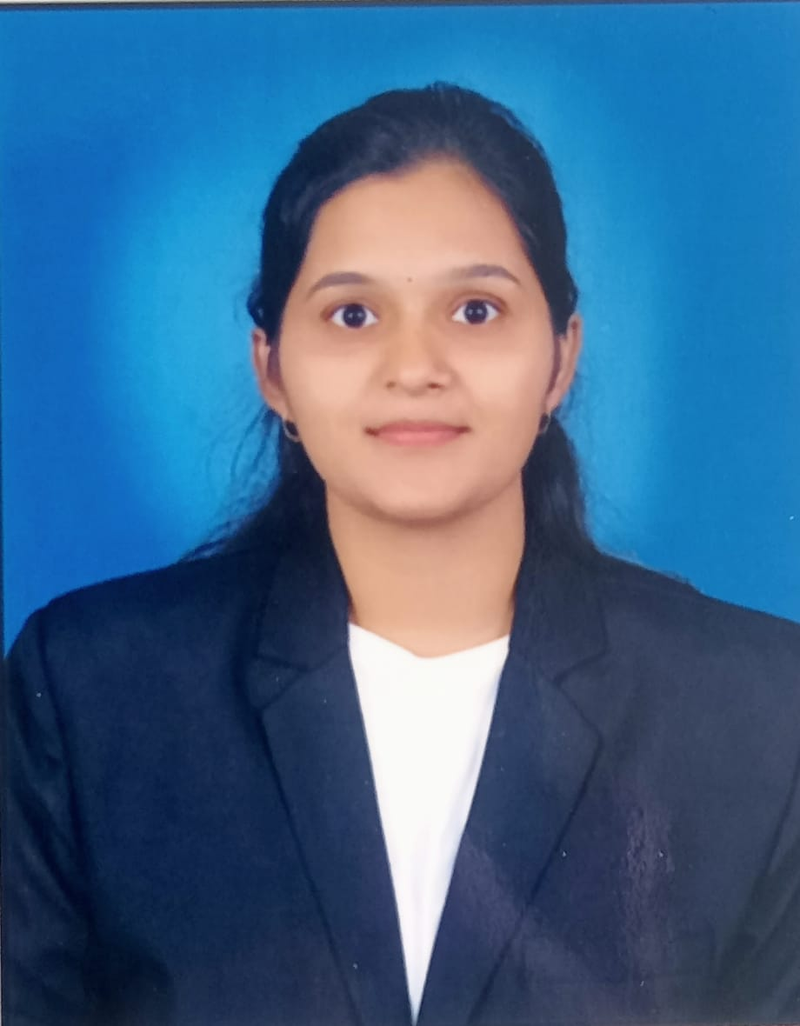
Education:
M.Pharm. (2025): Tatyasaheb Kore College of Pharmacy, Warananagar, Dist Kolhapur
B. Pharm. (2023): Annashaeb Dange College of Pharmacy, Ashta, Tal. Walwa, Dist. Sangli
Professional Work Experience:
From 1/9/2025 as a assistant professor in Annasaheb dange college of b pharmacy ,ashta (D.pharm) to till date
Teaching | Research | Industry |  | Total
Years Months | 00 Years | 00 Years |  | Years Months
Professional Affiliations:
Subject Taught: Diploma-, Hospital and clinical Pharmacy
Research Foci: Development of micellar nanodrug delivery system against cancer
Number of Research Projects: Nil |  |  | Grants Received: Nil
Number of Publications: Nil |  |  | Resource Person Presentations: Nil
Patent: 0
Selected Publications:

