Ms.Nagare Sharyu Babasaheb  Assistant Professor  CampusAddress:  SDSS,Annasaheb Dange College of BPharmacy (Diplomacourse),Ashta Tal.Walwa,Dist.Sangli(416301)  Phone:Office:02342-241124  E-mail:nagare.sharyuadcbp@gmail.com |  |  | 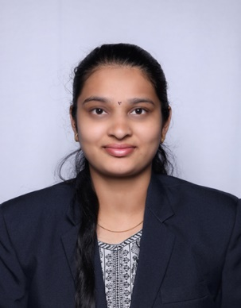
Education:
M.Pharmacy (2022)Ashokrao Mane College of Pharmacy, Peth Vadgaon
B.Pharmacy (2020)Ashokrao Mane College of Pharmacy, Peth Vadgaon
Professional Work Experience:

1. Work as Assistant Professor in Ashokrao Mane College of Pharmacy ,Peth Vadgaon.
Teaching | Research | Industry | Total
2.10 Years
ProfessionalAffiliations:RegisteredPharmacist(Registrationno.276856)
SubjectTaught:Diploma- Pharmacotherapeutics, Pharmaceutics
ResearchTopic.Stability Indicating method development and kinetic study of selected anti-asthmatic drug
Number of ResearchProjects:01 |  | Grants Received:Rs.-
Number of Publications:02 |  | Resource Person Presentations:-
Patent:-4
Book Published:-
Selected Publications:
- Overview of UV spectroscopy derivative, International Journal of Creative ResearchThoughts,IF7.97
- First line agents of anti-epileptics drugs and its impurities, Journal of Bio-innovation,IF4.9

