Mrs. Mote S. G., M.Pharm(Pharmaceutics)  Assistant Professor  Campus Address:  Annasaheb Dange College of B.Pharmacy  Ashta Tal. Walwa, Dist. Sangli (416301)  Phone: Office: 02342-241125  Fax: 02342-241125  E-mail: kharat.shubhangiadcbp@gmail.com |  |  | 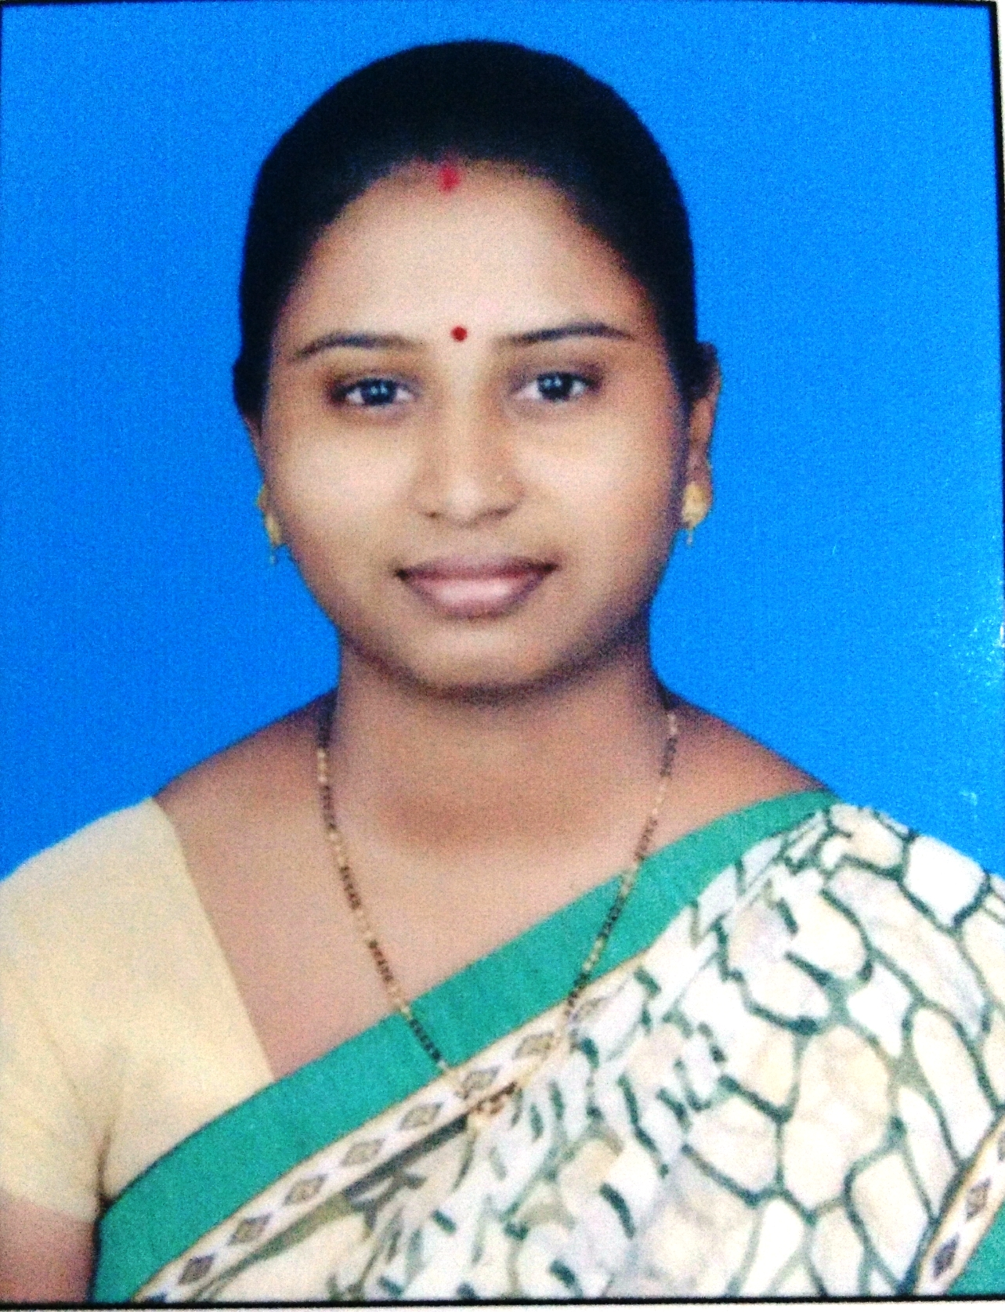
Education:
Ph D: Pursuing at Shivaji University, Kolhapur
M.Pharm. (2017): Arvind Gavali College of Pharmacy, Satara
B. Pharm. (2015): D.S.T.S Mandal’s College of Pharmacy, Solapur
Professional Work Experience:
01 July 2019 to till date: Assistant Professor in Pharmaceutics Dept, Annasaheb Dange College of B.Pharmacy, Ashta
Teaching | Research | Industry |  | Total
6.3 years |  |  |  | 6.3 years
Professional Affiliations: Registered Pharmacist (Registration No. 173792).
Subject Taught: UG- Biopharmaceutics and Pharmacokinetics, Physical Pharmaceutics- I, Pharmacy Practice
Research Foci: Formulation and Evaluation of dosage form containing silver nanoparticles, Novel Drug Delivery System, SNEDDS
Number of Research Projects: 00 |  |  | Grants Received: Rs. Nil
Number of Publications: 03+04+02 |  |  | Resource Person Presentations: 04
Selected Publications:
- Mote GD, Firodiya SR, Gaikwad MS, Bairagi SM, Kharat SS (2017). Formulation and evaluation of effervescent tablet of valsartan. International journal of pharmaceutics & drug analysis. 5(4), 136 – 143, impact factor: 0.5, ISSN No.:2348-8948.
- Kharat SS, Yadav VD, Jadhav PD, Mote GD (2018). Formulation and evaluation of hydrogel containing azithromycin and silver nanoparticles. Indo American Journal of Pharmaceutical Research, 8(1).1335-1346. Impact factor: 0.98, ISSN NO: 2231-6876.
- Mr. Ganesh D. Mote, Ms. Shubhangi S. Kharat (2022). A Practical textbook of Pharmaceutical Organic Chemistry II. Pritam Publications. ISBN NO: 978-93-92159-90-9.
- Method development and validation on RP-HPLC for assay of bulk and formulation of Carmustine. Patent number 202221051621 A. (2022)
- Mr. Ganesh D. Mote, Mr. Bharat B. Garande, Dr. Mahesh G. Saralaya, Mrs. Shubhangi G. Mote (2023). Textbook of Pharmaceutical Organic Chemistry -II (As per PCI syllabus). Orange Books Publication. ISBN No. 978-93-5621-818-5.
- Study of Impurity Profile of Aspirin in Bulk and Tablet Dosage Form. Patent number 202221051775 A (2023)
- Formulation & Evaluation of antifungal soap using Trachyspermum ammi. Patent number 202421001846. (2024)
- Design Patent ‘APPARATUS FOR RECOVERY OF RESIDUAL SOLVENTS BY AUTOMATED HPLC’ Design Number: 405954-001 (2024)
- Sravani Ravla, Priyanka Shelake, Nisha Jagtap, Shubhangi Kharat and Yasmin Momin. A Comprehensive Review: Pharmacological Activities of Isolated Bioactive Compounds from Different Species of Cucurbitaceae Plants. Indian Journal of Natural Sciences, Vol.15 / Issue 85 / Aug / 2024. ISSN: 0976 – 0997

