Ms. Nagare Sharyu Babasaheb Assistant Professor  Campus Address:  SDSS, Annasaheb Dange College of B Pharmacy (Diploma course), Ashta Tal. Walwa, Dist. Sangli (416301)  Phone: Office: 02342-241124  E-mail: nagare.sharyuadcbp@gmail.com |  |  | 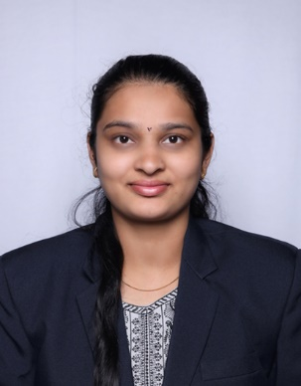
Education:
M. Pharmacy (2022) Ashokrao Mane College of Pharmacy, Peth Vadgaon
B. Pharmacy (2020) Ashokrao Mane College of Pharmacy, Peth Vadgaon
Professional Work Experience:

1. Work as Assistant Professor in Ashokrao Mane College of Pharmacy, Peth Vadgaon.
Teaching | Research | Industry | Total
1.9 Years
Professional Affiliations: Registered Pharmacist (Registration no. 276856)
Subject Taught: Diploma- Pharmacotherapeutics, Pharmaceutics
Research Topic. Stability Indicating method development and kinetic study of selected anti-asthmatic drug
Number of Research Projects: 01 |  | Grants Received: Rs. -
Number of Publications: 02 |  | Resource Person Presentations: -
Patent: -4
Book Published: -
Selected Publications:
- Overview of UV spectroscopy derivative, International Journal of Creative Research Thoughts, IF 7.97
- First line agents of anti-epileptics drugs and its impurities, Journal of Bio-innovation, IF 4.9

