Miss. Jamadar Aafrin Gous, M.Pharm.  Assistant Professor  Campus Address:  Sant Dnyaneshwar Shikshan Sanstha’s Annasaheb Dange College of B Pharmacy  Ashta, Tal. Walwa, Dist. Sangli (416301) Phone: Office: 02342-241125  E-mail: jamadar.aafrinadcbp@gmail.com | 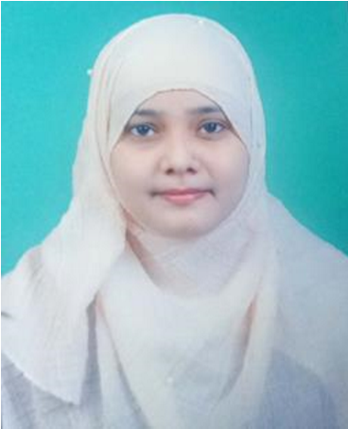
Education:
M.Pharm. (2023): Appasaheb Birnale College of Pharmacy, Sangli
B. Pharm. (2021): Annasaheb Dange College of B Pharmacy, Ashta
Professional Work Experience:
Assistant Professor at Annasaheb Dange College of B Pharmacy, Ashta from 1st September 2023.
Teaching Research Industry Total
0.5 year 0.5 year
Professional Affiliations: Registered Pharmacist (Registration No: 308267 );
Subject Taught: Diploma- Human anatomy and physiology, Pharmacology
Research Foci: Effect of Methanolic extract of Plumeria Pudica Jacq. Leaves against DMBA induced mammary carcinoma in rats
Number of Research Projects: 01 Grants Received: -
Number of Publications:-01 Resource Person Presentations: -
Patent:-- Selected
Publications:
1. Rukaiya Mulani , Zuber Choudhari , Ashutosh Pujari , Aafrin Jamadar ,Parvati Gugwade. ANTHELMINTIC PLANTS: A REVIEW.

