Ms. Nagare Sharyu Babasaheb Assistant Professor  Campus Address:  SDSS, Annasaheb Dange College of B Pharmacy (Diploma course), Ashta Tal. Walwa, Dist. Sangli (416301)  Phone: Office: 02342-241124  Cell No. 9356059224  E-mail: nagaresharyu29@gmail.com |  |  | 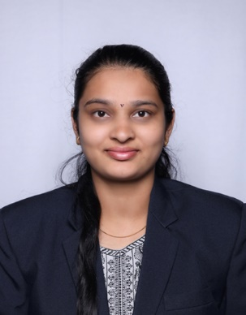
Education:
M. Pharmacy (2022) Ashokrao Mane College of Pharmacy, Peth Vadgaon
B. Pharmacy (2020) Ashokrao Mane College of Pharmacy, Peth Vadgaon
Professional Work Experience:

- Worked as Assistant Professor in Ashokrao Mane College of Pharmacy, Peth Vadgaon.
- Assistant Professor in Annasaheb Dange College of B.Pharmacy, Ashta from 03/07/2023 till date
Teaching | Research | Industry | Total
01 year 00 00 01 year
Professional Affiliations: Registered Pharmacist (Registration no. 276856)
Subject Taught: Diploma- Pharmacotherapeutics.
Research Foci. Stability Indicating method development and kinetic study of selected anti-asthmatic drug
Number of Research Projects: 01 |  | Grants Received: Rs. -
Number of Publications: 02 |  | Resource Person Presentations: -
Patent: -1
Book Published: -
Selected Publications:
- Aniket V. Katkar, Sharyu B. Nagare, Shubhangi B. Sutar, Dr.Sachinkumar V. Patil.Overview of UV spectroscopy derivative, International Journal of Creative Research Thoughts,volume 10,Issue 9 Sep 2022.
- Sneha S.Deshmukh, Sharyu B.Nagare, Shubhangi B. Sutar, Dr. Sachinkumar V. Patil, First line agents of anti-epileptics drugs and its impurities, Journal of Bioinnovation, Vol 11, 31 July 2022.

