Mr. Upadhye S.S., M.Pharm ( Ph D Pursuing)  HOD  Campus Address:  Sant Dnyaneshwar Shikshan Sanstha’s  ANNASAHEB DANGE COLLEGE OF B.PHARMACY [D. PHARM]  Ashta, Tal. Walwa, Dist. Sangli (416301)  Phone: Office: 02342-241125  Cell No. 9423560416  E-mail: ssupadhye7@gmail.com |  |  | 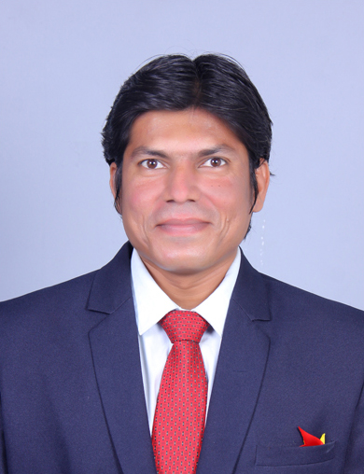
Education:
Ph D ( Pursuing): Sanjay Ghodawat University, Kolhapur.
M.Pharm. (2013): Ashokrao Mane College of Pharmacy, Peth-Vadgaon
B. Pharm. (2011): Tatyasaheb Kore College of Pharmacy, Warananagar, Dist Kolhapur
D.Pharm (2008): Dr. J.J. Magdum Pharmacy College, Jaysingpur, Dist:Kolhapur
Professional Work Experience:
July 2013 to June 2014: Production Department: Idomax Chemicals, Miraj
June 2014 to May 2019: Lecturer, Dr.J.J.M.T, Dr.J.J. Magdum Pharmacy College, Jaysingpur
July 2019 to till date: Assist. Professor, SDSS Annasaheb Dange College of B.Pharmacy (D.Pharm Course), Ashta
Nov 2021 to till date HOD (D.Pharm), SDSS Annasaheb Dange College of B.Pharmacy, Ashta (D.Pharm)
Teaching | Research | Industry |  | Total
09 Years 06 Months | 00 Years | 01 Years |  | 10 Years 06 Months
Professional Affiliations: Association of Pharmaceutical Teachers of India (MA/LM-2292); Registered Pharmacist (Registration No. 120473);Indian Pharmaceutical Association (MAH-KOLH-OM-13); Research Scholar Hub (RSH/IN/MH/LM-25/2014), Editorial Board Member of International Journal Of Pharmaceutical Research and Bio Science, Editorial Board Member of Advanced Journal of Pharmacie and Life science Research, Reviewer: World Journal of Pharmacy and Pharmaceutical Science, Reviewer of IJERT.
Subject Taught: Diploma- Pharmaceutics I, Pharmaceutics II, Drug Store & Business Management, Community Pharmacy and Management
Research Foci: Gastroretentive Drug Delivery System, Formulation & Evaluation of Anti-Ulcer Floating Tablet Using Swellable Polymers.
Number of Research Projects: Nil |  |  | Grants Received: Nil
Number of Publications: 42 |  |  | Resource Person Presentations: 16
Patent: 05
Selected Publications:
- Kadam AM, Upadhye SS, Honmane SM, Patil SV, Patil SS (2014): FORMULATION AND EVALUATION OF ANTI-ULCER FLOATING TABLET USING SWELLABLE POLYMERS: IJDD,2014 Volume 6(3)244-253.
- Kulkarni AA, Kothali B.K., Apte AK, Khot VS, Patil AA, Upadhye SS ,Danole AB (2015): EVALUATION OF IN-VITRO ANTHELMENTIC ACTIVITY OF MALLOTUS PHILIPPINENSIS MUELL, IJPRD, 2015; Vol 6(11): 011 – 014.
- Upadhye SS , Kothali B.K., Apte AK, Danole AB(2014): A REVIEW ON TECHNOLOGY TRANSFER IN PHARMACEUTICAL INDUSTRY : IJPRBS, 2014; Volume 3(6): 445-460
- Upadhye SS , Kothali B.K., Apte, Kulkarni AA, Khot VS, Patil AA (2014) Transdermal Drug Delivery System: An Overview: Am. J. PharmTech Res. 2014; 4(5):1-26
- Upadhye SS , Kothali B.K., Apte, Kulkarni AA, Patil AA (2015): GASTRO RETENTIVE DRUG DELIVERY SYSTEM: AN OVERVIEW: Am. J. PharmTech Res. 2015; 5(5):52-74
- Upadhye SS , Kothali B.K., Apte, Patil AA (2016): A REVIEW ON MICROSPONGE DRUG DELIVERY SYSTEM:IJPRBS: 2016; Volume 5(1): 152-166
- Upadhye SS , Kothali B.K., Apte, Kulkarni AA, Khot VS , Patil AA(2019): A REVIEW ON NANOROBOTS: Am. J. PharmTech Res. 2019; 9(2):11-20
- Shashikant Sudarshan Upadhye, Inamdar Nasruddin Rafik: Proniosomes: A Novel Vesicular Drug Delivery System: Am. J. PharmTech Res.;10(02): 2020.
- Thorat Sheela Shivaji, Mali Ramling Dnyaneshwar, Inamdar Nasruddin Rafik and Upadhye Shashikant Sudarshan: ANTIMICROBIAL AGENTS AND ANTIBACTERIAL ANTIBIOTICS: AN OVERVIEW: WORLD JOURNAL OF PHARMACY AND PHARMACEUTICAL SCIENCES: Volume 9, Issue 7, 839-867:2020.
- V. V. Gurav, S. S. Hande, A.V. Desai, V. Y. Rohile, N. R. Inamdar, S. S. Upadhye, Telmisartan Niosomes Design, Development and Characterization, IJPSR(2022), Volume 13 Issue 9: 1000-08

