Miss. Khairmode S.S., M. Pharm  Assistant Professor  Campus Address:  Sant Dnyaneshwar Shikshan Sanstha’s  ANNASAHEB DANGE COLLEGE OF B. PHARMACY, ASHTA  Tal. Walwa, Dist. Sangli (416301)  Phone: Office: 02342-241125  Cell No. 8421528564  E-mail: khairmode.shivaniadcbp@gmail.com  shivanisk007@gmail.com | 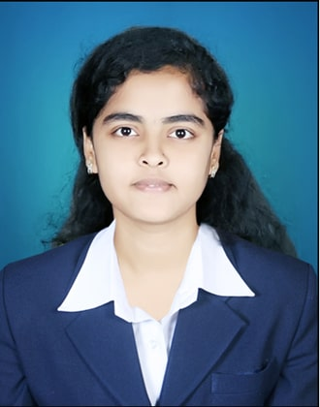
Education:
M. Pharm (2021): Bharati Vidyapeeth college of pharmacy, Kolhapur.
B. Pharm. (2019): Rajarambapu College of Pharmacy, kasegaon, Dist Sangli
Professional Work Experience:
November 2021 till date: Assist. Professor, SDSS Annasaheb Dange College of B. Pharmacy, Ashta (1.9 Year)
Professional Affiliations: Registered Pharmacist (Registration No. 256804)
Subject Taught: D. Pharm- Pharmaceutics, Pharmacotherapeutics
B. Pharm- Human Anatomy Physiology-I, Communication Skill
Research Foci: Green synthesis and evaluation of metallic phyto-nanoparticles
Number of Research Projects: Nil | Grants Received: Nil
Number of Publications: 4 | Resource Person Presentations: Nil
Patent: Nil
Selected Publications:
- Shivani Khairmode, Radha Khade, Firoj Tamboli*, Harinath More, Dhanashri Patil, Karuna Dhuri, Namrata Kanse, Shrinivas Mohite. Comparative studies on conventional and microwave assisted synthesis of N-(phenylcarbamothioyl) benzamide derivatives and its anti-inflammatory activity. International Journal of Chemical Science. 2021; 5(3):1-3.
- Tamboli, F., More, H., Khairmode, S., Patil, D., Tambare, P., Shinde, A., & Jadhav, N., CHYAWANPRASH: A traditional Indian bioactive herbal medicinal formulation to boost immunity and restore youthfulness. Tropical Journal of Pharmaceutical and Life Sciences, 2021, 8(1), 21-28.
- Tamboli, F., More, H., Khairmode, S., Patil, D., Tambare, P., Shinde, A., & Jadhav, N., Importance of medicinal plants and herbs as an immunity booster for pandemic COVID-19. Tropical Journal of Pharmaceutical and Life Sciences, 2021, 8(1), 01-09.
- Dhanashri Patil, Firoj Tamboli*, Harinath More, Shivani Khairmode, Prajakta Tambare, Pramila Patil, Shalaka Patil. Formulation and evaluation of valsartan buccal patches. International Journal of Pharmaceutical Science and Research.2021;6(1).30-33.

