Ms. Sravani Ravala (M.Pharm)  Assistant Professor  Campus Address:  Annasaheb Dange College of B.Pharmacy  Ashta, Tal. Walwa, Dist. Sangli (415409)  Phone: Office (02342) 241125,  Fax: (02342) 24106 Cell No. 9573306369  E-mail: ravala.sravaniadcbp@gmail.com | 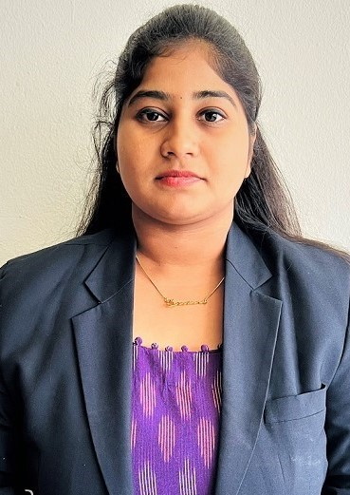
Education:
M.Pharm. (2022): Koneru lakshmaniah college of pharmacy, Vaddeswaram.
B. Pharm. (2020): Koneru lakshmaniah college of pharmacy, Vaddeswaram
Professional Work Experience:
Professional Work Experience:
September 2022 to till date: Assistant Professor, Annasaheb Dange College of B Pharmacy, Ashta.
Teaching | Research | Industry | Total
1 year | - | - | -

Professional Affiliations: -
Subject Taught: UG- -
Research Foci: formulation and Evaluation of Nifedipine transdermal drug delivery system.
Number of Research Projects: 01
Number of Publications: -
Publications:

