Ms. Jagtap N.M. ,M.Pharm.  Assistant Professor  Campus Address:  Sant Dnyaneshwar Sikshan Sanstha’s  Annasaheb Dange College of B Pharmacy  Ashta, Tal.Walwa, Dist. Sangli (416301)  Phone: Office: 02342-241125,  Cell No. 8421393821  E-mail:jagtap.nishaadcbp@gmail.com |  |  | 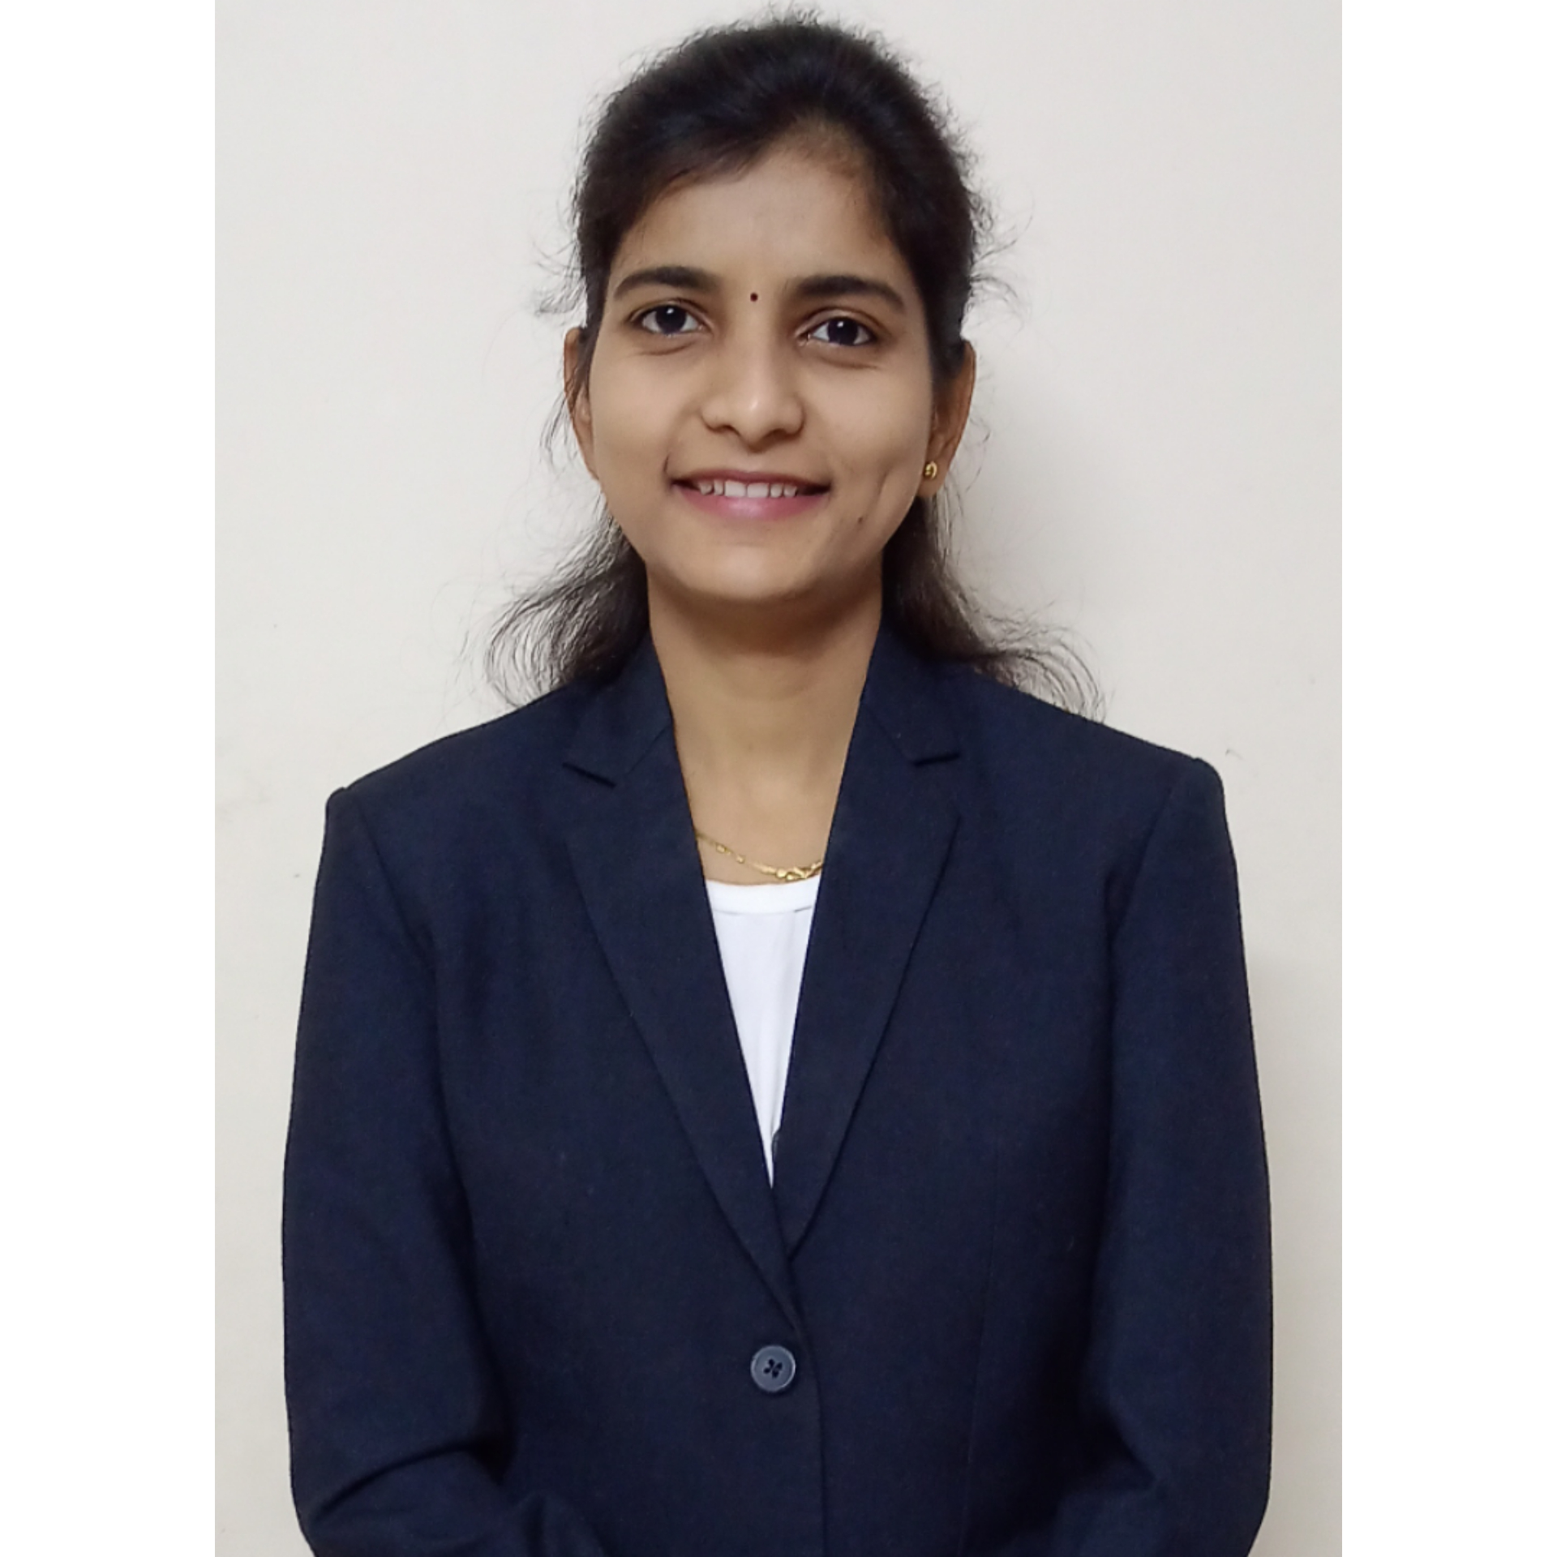
Education:
M.Pharm. (2021): Rajarambapu college of pharmacy,kasegaon
B. Pharm. (2018): Rajarambapu college of pharmacy,kasegaon
Professional Work Experience:
April 2021 to till date: Assistant Professor at Annasaheb Dange College of B Pharmacy, Ashta
Teaching | Research | Industry |  | Total
2 year 4 month | - | - |  | 2 year 4 month
Professional Affiliations: Registered Pharmacist (Registration No. 187782)
Subject Taught: UG- Instrumental methods of analysis, Pharmaceutical inorganic chemistry, Pharmaceutical organic chemistry-III
Research Foci: Molecular docking study, QSAR, Drug Design
Number of Research Projects: |  |  | Grants Received:
Number of Publications: 10 |  |  | Resource Person Presentations:
Patent:1,3,4-oxadiazole-2(3H)-thione derivatives as anticancer agents.
Selected Publications:
- Jagtap NM, Yadav AR, Mohite SK Synthesis molecular docking studies and anticancer activity of 1,3,4-oxadiazole-2(3H)-Thione Derivatives. Journal of University of Shanghai for Science and Technology 2020;22(11).
- Jagtap NM, Gavade AS, Vambhurkar GB, Kengar MD, Jagtap AM, PatilOA.Passiflora incarnate as Natural pH Indicator. Research Journal of Topical and Cosmetic Sciences. 2018; 9(1):04-06.
- Todkar RR, Patil PB, Jagtap NM, Vambhurkar GB, Gavade AS, Jagtap NM, Ambekari AD, Thorat AM. Flame Lily as Natural pH Indicator. Asian Journal of Pharmaceutical Analysis. 2019; 01(09):5-7.
- MN Ghotkar, SS Kharade, RS Chavan, RS Jadhav, Jagtap NM,VambhurkarGB.Formulation and Evaluation of Herbal Facewash for Acne.Asian Journal of Pharmaceutical Analysis 2018; 8(4), 183-185.
- Jagtap AM, Gavade AS, Vambhurkar GB, Kengar MD, Jagtap NM, Patil OA.Zinnia bicolor as Natural pH Indicator.Asian Journal of Pharmaceutical Analysis 2018;8(3),137-139.
- Suryawanshi VS, Yadav AR, Jagtap NM,Birajdar RM, Vambhurkar GB, PatilPA.Optimization of Ayurvedic Herbal Medicines by Nanoformulation. Asian Journal of Research in Pharmaceutical Science 2019; 9(1),55-56.

