Ms. Shelake P.R. (M.Pharm)  Assistant Professor  Campus Address:  Annasaheb Dange College of B.Pharmacy  Ashta, Tal. Walwa, Dist. Sangli (415409)  Phone: Office (02342) 241125,  Fax: (02342) 24106 Cell No. 8855917896  E-mail: shelake.priyankaadcbp@gmail.com | 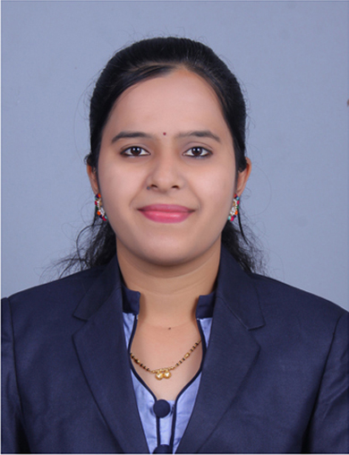
Education:
PhD: Pursuing from Shivaji University
M.Pharm. (2016): Appasaheb Birnale college of pharmacy, Sangli.
B. Pharm. (2014): Appasaheb Birnale college of pharmacy, Sangli.
Professional Work Experience:
Professional Work Experience:
August 2016 to 2019: Assistant Professor, Appasaheb Birnale college of pharmacy, Sangli.
July 2019 to till date: Assistant Professor, Annasaheb Dange College of B Pharmacy, Ashta.
Teaching | Research | Industry | Total
6.10 Years | - | - | 6.10 Years

Professional Affiliations: Registered Pharmacist (Registration No. 216981)
Subject Taught: UG- Pharmaceutical Microbiology, Pharmaceutical Engineering, And Pharmaceutical Unit Operations. Pharmaceutical Jurisprudence’.
Research Foci: formulation and Evaluation of self-emulsifying drug delivery system class Antidepressant. .
Number of Research Projects: 01
Number of Publications: 03
Publications:
- Formulation and Evaluation Of Solid Self Emulsifying Drug Delivery System For Drug Mirtazapine. R. Shelake ^{* 1}, R. R. Shah ¹, V. V. Nalawade ² And P. P. Majalekar Department Of Pharmaceutics ¹, Department Of Pharmaceutical Chemistry ², Appasaheb Birnale College Of Pharmacy, South Shivaji Nagar Opposite Income Tax Office, Sangli - 416416, Maharashtra, India.

- Design, synthesis and comparative pharmacological assessment of novel fluoroquinoline derivatives. Int J Pharm Sci &amp; Res 2019; 10(8): 3735-40. doi: 10.13040/IJPSR.0975-8232.10(8).3735-40. Majalekar PP, Shirote P, Nalawade V and Shelake P:

- Phytochemical Evaluation And Pharmacological Screening Of Abutilon Indicum Sweet Leaves Extract Vidya Nalawade1 *, Dr. Pramodkumar Shirote2 , Priyanka Majalekar3 , Priyanka Shelake4 , Vikram Nalawade Volume 7, Issue 5, 1380-1389 Research Article Issn 2278 – 4357

