Mrs. Pratibha S Kamble  Librarian  Campus Address:  Near Old Airport,  Annasaheb Dange College of B Pharmacy, Ashta  Ashta Tal. Walwa, Dist. Sangli (416301)  Phone: Office: 02342-241125  E-mail: pratibhakamble33@gmail.com |  |  | 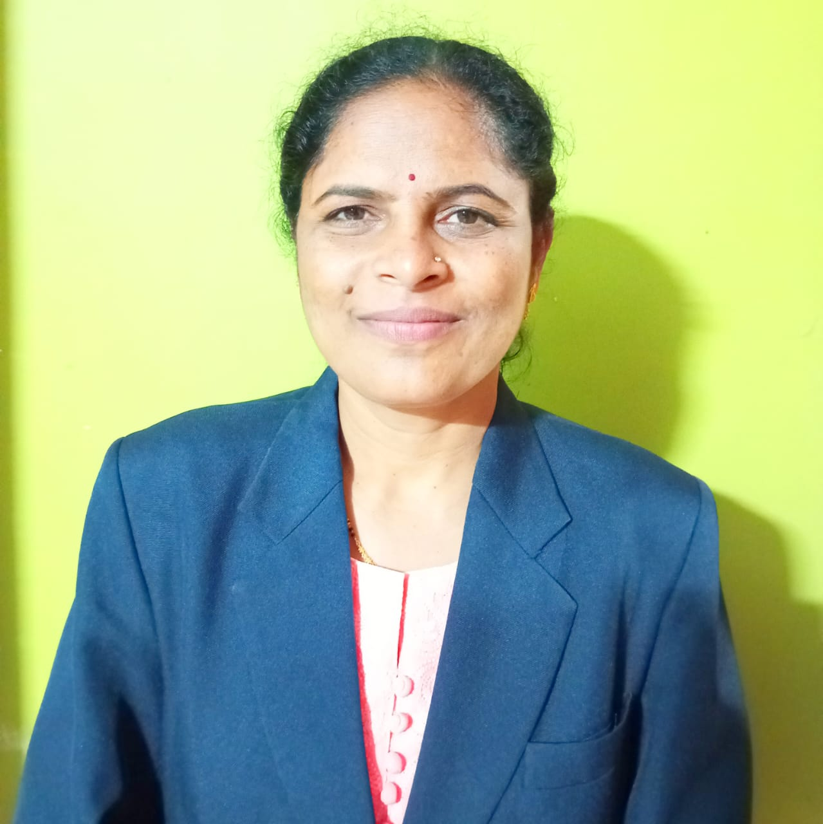
Education:
MA (Sociology) (2004): Shivaji University, Kolhapur.
MLIB & ISc (2009): YCMOU Nashik.
UGC NET (2014): UGC New Delhi
PhD (Persuing) : Sant Gadagebaba Amaravati University, Amaravati.
Professional Work Experience:

Teaching | 2.5 Yrs. |  |  | Total
Professional | 3.7 Yrs. |  |  | 6.2 Years
Professional Affiliations: Member of Shivaji University College Librarians Association (SUCLA)
Member of Maharashtra College Librarians Association (MUCLA)
Professional ICT Skills:

Operating Systems : Windows 98/XP/7/8/10, Red Hat Linux Office Suites : MS Office (MS Word, Excel, PowerPoint etc.)
Programming Language : HTML, Digital Library S/W: DSpace Library S/W Package : Libsys, Vidyasagar, Koha.
Project:

Project completed in PG Level: Study of Computerization of Library in Various Engineering Colleges in Kolhapur District.
Project includes study of Software, Hardware, Network and other accessories used for Automation of Library. Also includes suggestion given to improve the Automation.

Paper Presentation: 4 Nos.

- Participated in National Level Seminar on” Emerging Trends in Library Technology” held in August 2015 at Shri Shahu Chatrapati Mahavidyalaya Kolhapur. National Level Paper presented on “Library Automation”. ISBN: 978-81-927211-0-7
- Participated in National Level Seminar on “Changing Trends in Library & Information Science” held in Dec 2015 at Dr. Patangrao Kadam Mahavidyalaya, Sangli.National Level Paper presented on “Digital Library”. ISBN: 978-81-924895-1-3
- Participated in National Level Seminar on “Professional Challenges & Opportunities for Development of College Librarians held in August 2020 organized by Shivaji University College Librarian’s Association (SUKLA). National level paper presented on “Use of Open Source Softwares in Library Automation. ISBN: 978-93-81249-30-7.
- Participated in National Seminar on “Revamping Libraries in Modern Era in in July 2023 organized by Shivaji University Kolhapur. National level paper presented on “ Sustainable Development: Green Libraries”.

Seminar/Workshop: 4 Nos.
- One Day Orientation Programme attended on "API for College Librarians and Introduction to DSpace for Building Institutional Repository" at Shivaji University Kolhapur.
- One week National Level Workshop attended on “Design & Development of Institutional Repository/Digital Library using DSpace” at Shivaji University Kolhapur.
- One Day Workshop attended on "Persons with Disabilities on Inclusion, Education and Accessility” jointly organized by Barr. Balasaheb Khardekar Library & Resource Centre for Inclusive Education, Shivaji University Kolhapur.
- One Day Workshop attended on "Management of Change for College Librarians affiliated to Shivaji University, Kolhapur” organized by Library & Information Science department, Vivekanand College, Kolhapur.

