Dr. Mahesh G Saralaya., M.Pharm., Ph.D.  Principal and Professor  Campus Address:  Sant Dnyaneshwar Sikshan Sanstha’s  Annasaheb Dange College of B Pharmacy  Ashta, Tal. Walwa, Dist. Sangli (416301)  Phone: Office: 02342-241125,  Cell No. 9265789039  E-mail: mahesh.saralayaadcbp@gmail.com |  |  | 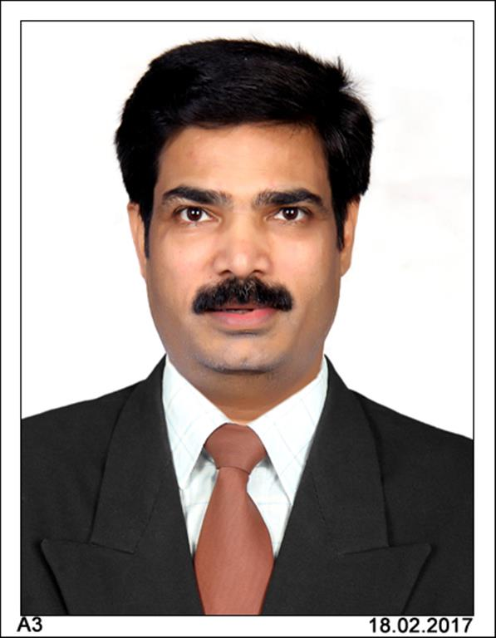
Education:
Ph.D. (2007): Department of Pharmaceutical Technology (Jadavpur University) Kolkata.
M.Pharm. (1997): K.L. E’s College of Pharmacy (Karnataka University Dharwad), Belgaum
B. Pharm. (1994): K.L. E’s College of Pharmacy (Karnataka University Dharwad), Belgaum
Professional Work Experience:
July 2021 to till date: Principal and Professor at Annasaheb Dange College of B Pharmacy, Ashta.Sangli
Teaching | Research | Industry |  | Total
26.5 Years | 10 Years | - |  | 26.5 Years
Professional Affiliations: 1. Life member of association of Pharmaceutical Teachers of India (APTI) KA/LM-211
2. Life Member of CEGR Membership number LT804
3. Life Member of Association of Indian College Principals (LM 462)
Subject Taught: UG- Human Anatomy and Physiology, Pathophysiology, Pharmacology PG: Cellular and Molecular Pharmacology, Advances in pharmacology
Research Foci: Carcinogenesis, novel anticancer agents from synthetic and plant sources and their targets
Number of Research Projects: 01 |  |  | Grants Received: Rs.1,50,000
Number of Publications: 36 |  |  | Resource Person Presentations: 06
Patent: 03 Book Published : 01
Selected Publications:
- P Suresh kanna, M G Saralaya, K Samanta, M Chatterjee “Vanadium inhibits DNA-protein cross-links and ameliorates surface level changes of aberrant crypt foci during 1, 2- dimethylhydrazine induced rat colon carcinogenesis“Cell Biol Toxicol.2005 Jan;21(1):41-52
- Tridib Chakraborty, Amrita Chatterjee, M.G. Saralaya, D. Dhachinamoorthi, Malay Chatterjee “Vanadium inhibits the development of 2-acetylaminofluoreene-induced premalignant phenotype in two stage chemical rat hepatocarcinogenesis model" Life Sci.2006 May 8;78(24):2839-51.
- Tridib Chakraborty, Amrita Chatterjee, Mahesh G Saralaya, D. Dhachinamoorthi, Malay Chatterjee “Chemopreventive effect of vanadium in a rodent model of chemical hepatocarcinogenesis: reflections in oxidative DNA damage, energy-dispersive X-ray fluorescence profile and metallothionein expression” J Biol Inorg Chem.2006 Oct;11(7):855-66
- Saralaya, Mahesh G, Patel, Paras, Manish Patel Samresh PalRoy, Patel, Asish N "Antidiarrheal Activity of Methanolic Extract of Moringa oleifera Lam Roots in Experimental Animal Models" IJPR 2010 ;2(2) 35-39
- Saralai Mahesh Patel Mital, Harde Pinal “A REVIEW ON ENDANGERED PLANT SPECIES AND THEIR CONSERVATION STRATERGIES” Plant Activa 2011; 2011( 4) 1-5
- Bangar, Amarnath V Saralaya, MG “Anti-hyperglycaemic activity of ethanol extract and chloroform extract of Indigofera tinctoria leaves in streptozotocin induced diabetic mice (Family-Papilionaceae)” Research Journal of Pharmaceutical, Biological and Chemical Sciences Jan 2011; 2(1): 445-455.
- G B Sonara, MG Saralaya, NK Gheewala,BB Sutariya "DEVELOPMENT AND VALIDATION OF HPTLC METHOD FOR SIMULTANEOUS QUANTIFICATION OF BIOMARKER IN POLY HERBAL AVALEHA FORMULATION “Inventi Rapid: Pharm Analysis & Quality Assurance 2012; 1 (2) 24-31.
- GB Sonara, MG Saralaya "Phytochemical evaluation of arial part of Leptadenia reticulata (Retz) for poly phenolic compound and free scavenging activity" Journal of Current Pharma Research 2012 ; 3 ( 1); 727: 2230-7834.
- GB Sonara, MG Saralaya, NK Gheewala" ANTIHISTAMINIC, ANTI ALLERGIC AND MAST CELL STABILIZING EFFECT OF PHYTOSTEROL RICH FRACTION OF AERIAL PART LEPTADENIA RETICULATA (RETZ)" Inventi Rapid: Planta Activa 2012;1(3)18-23.

