Ms. Momin. S.S (M. Pharm)  Assistant Professor  Campus Address:  Sant Dnyaneshwar Shikshan Sanstha’s  ANNASAHEB DANGE COLLEGE OF B. PHARMACY [D. Pharm COURSE]  Ashta, Tal. Walwa, Dist. Sangli (416301)  Phone: Office: 02342-241125  Cell No. 8623878446  E-mail: momin.sadiyaadcbp@gmail.com | 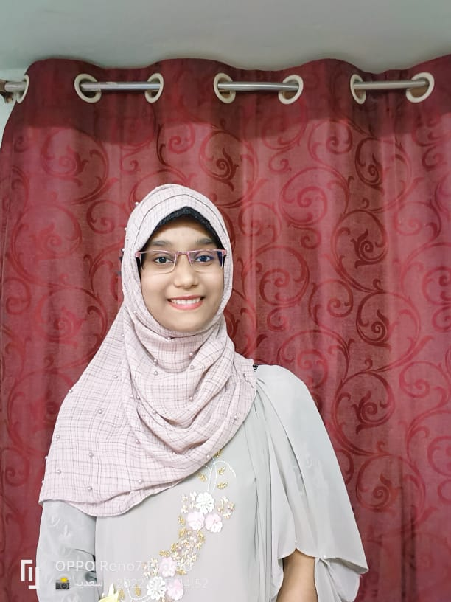  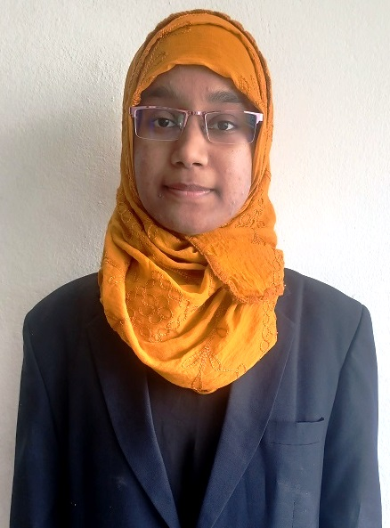
Education:
M. Pharm (2022): Government College of Pharmacy, Aurangabad
B. Pharm. (2020): Government College of Pharmacy, Karad
D. Pharm (2017): S. D. Patil Institute of Pharmacy, Urun-Islampur

Professional Work Experience:
September 2022 till date: Assist. Professor, SDSS Annasaheb Dange College of B. Pharmacy (D. Pharm Course), Ashta

Professional Affiliations: Registered Pharmacist (Registration No.)
Subject Taught: Diploma- Pharmacy Law and Ethics
Research Foci: Ursolic acid microsponges for topical application, Nanotechnology and Nanomedicines
Number of Research Projects: Nil | Grants Received: Nil
Number of Publications: Nil | Resource Person Presentations: Nil
Patent: Nil

