Mr. Surve A. B., M.Pharm  Assistant Professor  Campus Address:  Sant Dnyaneshwar Sikshan Sanstha’s  Annasaheb Dange College of B Pharmacy  Ashta, Tal. Walwa, Dist. Sangli (416301)  Phone: Office: 02342-241125,  Cell No.9545775697  E-mail: surve.anikethadcbp@gmail.com |  |  | 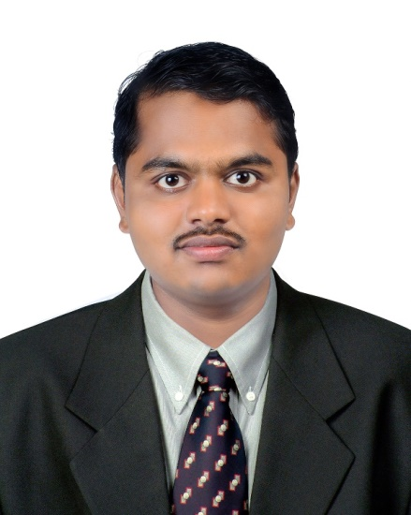
Education:
M.Pharm. (2020): Marthawada mitra mandal’s college of pharmacy,Pune
B. Pharm. (2018): Appasaheb Birnale College of Pharmacy, Sangli.
Professional Work Experience:
- Work as Assistant Professor in Eklavya College of Pharmacy, Tasgoan From 1 Nov 2020 to 30-05-2022.
- Work as Assistant Professor in Annasaheb Dange College of B Pharmacy, Astha From 1 jun 2022

Teaching | Research | Industry |  | Total
1.6 Years | - | - |  | 1.6
Professional Affiliations:); Registered Pharmacist (Registration No. 228903);
Subject Taught: UG- Pharmacognosy, Pharmaceutical Analysis, Pathophysiology, Herbal Drug Technology
Research Foci: Quality control of Herbs and Herbal formulations, Chromatographic analysis of herbs, Plant tissue culture for production of secondary metabolites.
Number of Research Projects: |  |  | Grants Received:
Number of Publications: 04 |  |  | Resource Person Presentations: -
Patent: 01
Selected Publications:

- Surve A. B,Phutane A.U,Patil M.J, Unani-the Dosage form the Review Article Publish in Boston Publication at Journal of Pharmacy and Experimental Medicine in Year. 2022, Vol. 2, Issue
- Surve A. B,Phutane A.U,Patil M.J, Caffiene the Physical Dependence the Review Article Publish Boston Publication at Journal of Pharmacy and Experimental Medicine in Year. 2022, Vol. 2, Issue 2 2(2);1-4
- Surve A. B, Phutane A.U, Patil M.J, Preparation and Standardization of Mayurchandrika Bhasma Research Article Publish in Boston Publication at World Journal of Plant Science and Research Technologies in Year. 2022, Vol. 1, Issue 1. 1(1);1-3
- Surve A.B,Phutane A.U, Saralaya M G,H1 Schedule –The Review,Article Publish at International Journal of Pharmaceutical Research and Analysis in Year 2022, Volume 7, Issue 3, : 1393-1395

