Dr. Momin Y.H., M.Pharm, Ph.D  Assistant Professor  Campus Address:  Sant Dnyaneshwar Shikshan Sanstha’s  ANNASAHEB DANGE COLLEGE OF B. PHARMACY  Ashta, Tal. Walwa, Dist. Sangli (416301)  Phone: Office:02342-241125.  Cell No. 8805280796; 8668201729.  E-mail: mullays413@gmail.com; momin.yasminadcbp@gmail.com |  |  | 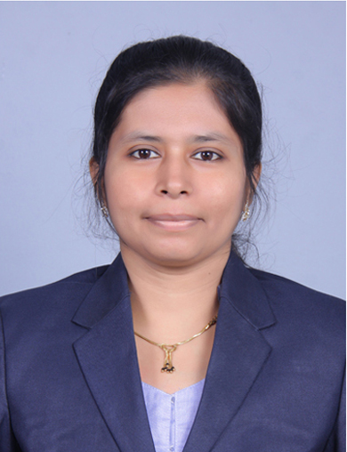
Education:
Ph.D.(2022): Shivaji University, Kolhapur
M.Pharm. (2010): Bharati Vidyapeeth College of Pharmacy, Kolhapur
B. Pharm. (2008): Shree Santkrupa College of Pharmacy, Ghogaon Tal Karad, Dist Satara.
Professional Work Experience:
July 2013 to July 2016: Assistant Professor, MSS College of Pharmacy, Medha, Satara.
July 2016 to till date: Assistant Professor, Annasaheb Dange College Pharmacy, Ashta
Teaching | Research | Industry |  | Total
8.10 Years | 6.00 Years | 00 Years |  | 8.10
Professional Affiliations: Live member of APTI (ID: MA/LM-2521), Registered Pharmacist (Registration No. 142821).
Subject Taught: UG- As per Shivaji University syllabus: Medicinal Chemistry I, Medicinal Chemistry III, Medicinal
Chemistry IV, Pharmaceutical analysis IV, Pharmaceutical Biochemistry, Pharmaceutical Chemistry,
Pharmaceutical Organic Chemistry,
As per PCI Syllabus: Biochemistry, Medicinal Chemistry I, PA I, POC I
Research Foci: Computational Chemistry, Synthetic Chemistry, Natural product research, Green Synthesis of nanoparticles from plant extracts.
Number of Research Projects: 00 |  |  | Grants Received: Travel grant (10,000)
Number of Publications: 09, Books: 01 |  |  | Resource Person Presentations: 01
Patent: No
Publications:
- Momin Y.H., Khunte A.A. (2015) Pharmacovigilance: An Essential Tool. International J. Current Pharma. Sciences, 1(3), 178
185.
- Momin Y.H., Bhatia M.S. (2016) Three-dimensional Quantitative Structure-activity Relationships Studies on a Series of Anticoagulants. Inventi Impact: Mol. Modeling, 2, 63-67.

- Dange Y.D., Salunkhe V.R., Bhinge S.D., Bhutkar B.R., Momin Y.H. (2017) Simultaneous equation method for the estimation of Palbociclib and Letrozole by UV-Visible spectrophotometry. Indian drugs, 9(54), 61-66.

- Momin Yasmin Hamid, Yeligar Veerendra Channabasappa. (2019) Antidiabetic and antioxidant activity of Coccinea grandis Voigt stem extract in streptozotocin induced diabetic rats. J Drug Delivery and therapeutics, 9 (4-A), 390-395.

- Y. H. Momin, V. C. Yeligar (2020) Gas Chromatography-Mass Spectrometry Analysis of Chloroform Extract of Coccinia grandis Voigt. Research J. Pharm. and Tech. 13(12), 5889-5892.

- Yasmin H. Momin, Veerendra C. Yeligar (2021) Synthesis of Coccinia grandis (L.) Voigt extract's silver nanoparticles
and it’s in vitro antidiabetic activity. J. Applied. Phar. Sci, 11(08), 108-115.
Books:
- Yasmin Momin, Sanjaykumar Bari, Dhanraj Jadge, Veerendra Yeligar (2019) Textbook of Pharmaceutical analysis I as per revised PCI syllabus. CBS Publishers and distributors PVT.LTD.

